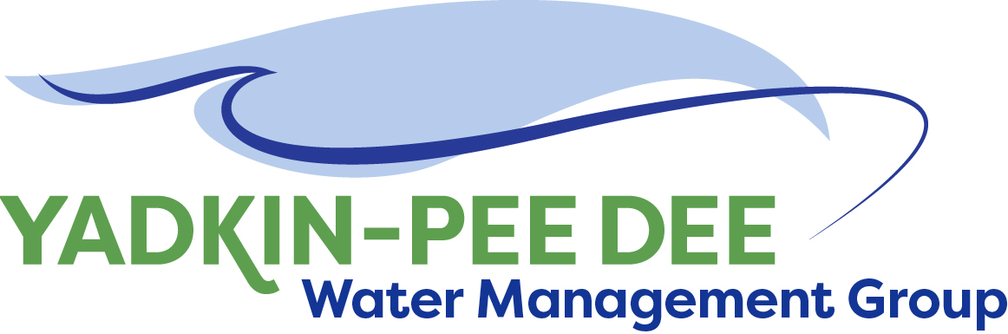
Yadkin-Pee Dee Water Management Group

Meeting Notes
Yadkin-Pee Dee Water Management Group
12:00 PM-2:30 PM, June 9, 2022
via Zoom

Agenda
- Welcome
- Roundtable Discussion
- Approval of April Meeting Minutes
- Water Resources Plan Update
- Nonprofit Subcommittee Update
- SC River Basin Council Update
- Next Steps & Adjourn

Welcome
Chair Aubrey Lofton of Union County began the meeting by thanking everyone and briefly reviewed the agenda for the meeting.

Roundtable
Next, Lofton began roll call and opened the meeting up for the Group’s roundtable discussion.
- Josh Canup is a new participant, and noted he is acting as a representative for the county commissioners and planning director.
- Jim Behmer of Salisbury-Rowan Utilities (SRU) noted his organization is putting the final touches on their water treatment plant, having rehabilitated all twelve filters and more. Behmer noted that SRU may host a tour at the next in-person meeting of the YPDWMG.
- Hyong Yi shared that Union County Water has spent over 14 hours with elected officials in recent weeks regarding proposed rate increases.
- Johnny Lambert of Davie County noted that all wastewater from the Town of Bermuda Run side of the county will go to Winston-Salem’s Muddy Creek Plant. Davie County will soon be releasing project bids for a water treatment plant, as Mocksville’s plant will be taken offline.
- Gerald Faulkner of Kannapolis shared that his organization will have a large project coming up to bid in January to get more water storage.
- Aubrey Lofton of Union County shared that Union County is near approval to move forward with a new 6MGD wastewater facility.

April Meeting Minutes Approval
Next, Chair Lofton asked for a motion to the approval of minutes from the Group’s April meeting. Jim Behmer made a motion to approve the minutes, seconded by Hyong Yi. The minutes were approved unanimously.

Water Resources Plan Update
Sara Yeh of HDR then provided several brief updates.

Jonathan Williams is no longer working at HDR. Yeh noted that she, along with David Saunders, will continue to support the Group and provide technical expertise. Sabrina Colón will continue to support communication work.

HDR has received a singular draft copy of the OASIS model from the state to begin modeling work. Once the closing stages of execution with the City of Winston-Salem are complete, that work will begin. Ed Bruce of Duke Energy asked if the Group’s inputs to the model would be sent back to the state; Yeh clarified that any modifications are linked back to the state’s hosting server, so the state would be able to receive any changes and view it as desired. The full version of the model is still not available on public servers.

Nonprofit Committee Update
Next, Warren of Fountainworks shifted to discussing the Group’s efforts to incorporate as a nonprofit entity. As the Group worked in 2020-2021 to examine its structure, it decided to extend the MOU to give itself more time, but the general agreement was that incorporating as a nonprofit entity would give this group a better sense of permanence, provide access to more funding opportunities, and help it to be more sustainable over the long-term. Over the past several months, a committee has been meeting to help work through a set of draft bylaws. These bylaws were modeled after those of the Catawba Wateree Water Management Group (CWWMG)’s, as many YPDWMG members have already approved the CWWMG’s. The nonprofit committee used the YPDWMG’s current MOU and existing documentation to help customize the bylaws.

A set of draft bylaws was presented to the Group at the April meeting. Members had one month to provide feedback, much of which was incorporated in the most recently shared version. The only area with disagreement was Section 12 surrounding fees. Warren Miller of Fountainworks recommended the Group pass on the draft bylaws to an attorney workgroup and have a separate committee of YPDWMG to continue working on a favorable fee structure.

Aubrey Lofton noted that she has been reaching out to members and understood that several organizations missed a cutoff for the proposed fee tiers by just a few hundred connections. Hyong Yi noted that it may be helpful to use a calculation (vs. a tiered approach). Jim Behmer noted that the Yadkin-Pee Dee River Basin Association calculates its dues based on permitting capacity. Gerald Faulkner of Kannapolis also noted the desire to find a more agreeable fee structure.

Ed Bruce of Duke Energy cautioned the Group that forming an attorney workgroup may take longer than expected and wanted to ensure there is adequate structure for the process. Fountainworks offered to convene a kickoff meeting of member attorneys to orient them to the background and purpose, including reviewing the suggestions already made by Duke Energy’s attorney, Garry Rice. The bylaws would then be handed off to the attorney workgroup, with hopes of receiving a “clean” version back by the August meeting.

It should be noted that by June 2023, the City of Winston-Salem will no longer be able to manage the Group’s finances.

Johnny Lambert made a motion to vote on officially beginning the steps toward incorporation, seconded by Hyong Yi. All present members voted in favor, none opposed.

SC River Basin Council Update
The South Carolina Department of Natural Resources (SCDNR) has responsibility over water supplies in eight basins in the state. They have drafted a plan that calls for a council in each basin to work with stakeholders and develop a long-range River Basin Plan. While YPDWMG cannot serve on the Yadkin River Basin Council as a member, it will serve as an advisory member. In March, Ron Sink and Aubrey Lofton attended two public kickoff meetings.

Ed Bruce of Duke Energy shared several updates. SCDNR has appointed the River Basin Council, with about 25 members. John Crutchfield of Duke Energy was appointed as a member, and will mostly look after his organization’s interests in a nuclear plant near Hartsville, SC. Ed Bruce will serve as the alternate. The first meeting in on June 28th. Aubrey Lofton will be attended as an advisory member on behalf of the YPDWMG.

Other Updates and Next Steps
Before the meeting closed, Sara Yeh of HDR noted that the Catawba Wateree Water Management Group (CWWMG) is planning to submit a comment letter to NC DEQ requesting amendments to the NC Drinking Water State Revolving Fund (SRF) Intended Use Plan (IUP) for set asides to include funding for (1) the development and maintenance of long-term water supply master plans and (2) water loss management and assessments. The CWWMG Board suggested reaching out to the YPDWMG to see if the organization is interested in submitting a similar letter or perhaps being referenced in the CWWMG’s letter as another entity that would support this allocation of funds.

The members agreed to send a letter modeled after the CWWMG’s comments.

As next steps, Fountainworks will convene a workgroup of attorneys and organize a kickoff meeting to refine the bylaws into an official legal document. Fountainworks will also convene a committee to determine a fee structure agreeable to all members.

A poll will be sent to determine the meeting dates for the remainder of the year.

The meeting adjourned at 2:01 PM.

Meeting Attendees
Gerald Faulkner, City of Kannapolis
Joyce Foster, Cube Yadkin
Ron Sink, Davidson Water
Johnny Lambert, Davie County
Ed Bruce, Duke Energy
David Rankin, City of Monroe
Josh Canup, Rowan County
Jim Behmer, Salisbury-Rowan Utilities
Andy Smith, City of Statesville
Aubrey Lofton, Union County
Hyong Yi, Union County

Non-Member Attendees:
Warren Miller, Fountainworks
Maddie Shea, Fountainworks
Sabrina Colón, HDR
David Saunders, HDR
Sara Yeh, HDR

