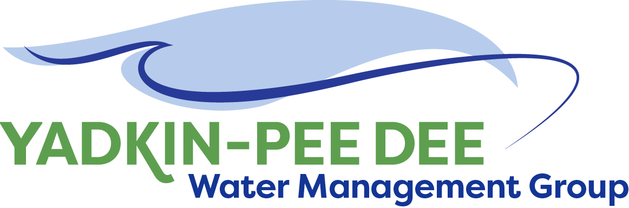
Yadkin-Pee Dee Water Management Group

AGENDA
Yadkin-Pee Dee Water Management Group Meeting
1:00PM to 2:30PM, August 19, 2021
Zoom: Link
City of Albemarle
Water & Sewer Authority of Cabarrus County
City of Charlotte
City of Concord
Cube Yadkin Generation
Davidson County
Davidson Water, Inc.
Davie County
Duke Energy
City of Kannapolis
City of Monroe
Montgomery County
Rowan County
Salisbury-Rowan Utilities
City of Statesville
Union County
Town of Wilkesboro
City of Winston-Salem/
Forsyth County

Welcome and Review of Agenda Jim Behmer, Chair
- Approve minutes from June 24th meeting

Roundtable Updates All

Update from HDR Jonathan Williams / Sara Yeh / All
- Duke Energy Foundation Grant Application
- WRP Messaging Guide & Outreach Materials
- State Model Update

Review Draft Annual Report Warren Miller / All

Adjourn

