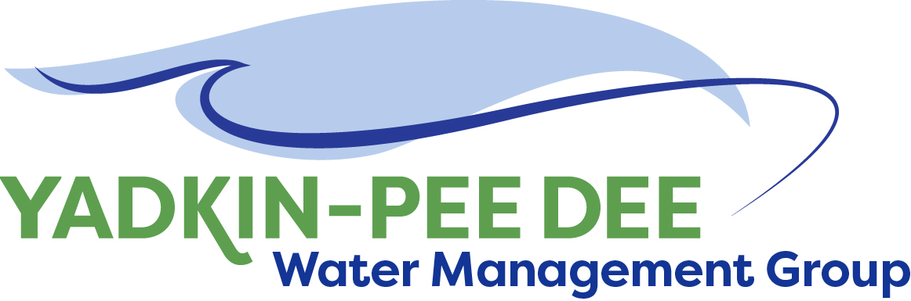
Yadkin-Pee Dee Water Management Group

Meeting Notes
Yadkin-Pee Dee Water Management Group Meeting
1:00PM to 2:30PM, August 19, 2021
Virtual Meeting (Zoom)

Agenda
- Welcome & Review of Agenda
- Roundtable Updates
- Update from HDR
  - Duke Energy Foundation Grant Application
  - WRP Messaging Guide & Outreach Materials
  - State Model Update
- Review Draft Annual Report

Welcome & Review
Chair Jim Behmer of Salisbury-Rowan Utilities opened the meeting, thanking participants for their attendance and commitment to the Group. He welcomed new attendee Sarah Mason, Environmental Scientist for Water Environment Consultants in near Charleston, South Carolina. Mason shared that her organization has a strong interest in how the Basin interacts with all its neighbors and is interested in how the two states can work together for mutual benefit as water is a shared resource.

The meeting minutes from the June 24th meeting were approved unanimously.

Roundtable Updates
Next, Behmer opened the roundtable discussion to hear general updates from the Group.
- The City of Salisbury hosted a vaccination clinic for employees, and the city manager provided an incentive of three days annual leave for employees who can prove their vaccination status. Behmer noted that the Delta variant of COVID-19 is anticipated to peak in mid-late September or early October, and that he is currently anticipating that restrictions and mandates will only come from the local level.
- Russell Colbath of City of Monroe asked if others had performed monitoring for cyanotoxin, mostly aligned with the UCMR 4, in raw or finished water along EPA health advisory guidelines. Bill Brewer of Winston-Salem shared that years ago, the City ran into issues at the PW Swann Water Treatment Plant with cyanotoxin sampling. Winston-Salem did have some detections in raw water, but not finished, and believes the chlorine oxidizes compounds. Ron Hargrove of City of Charlotte noted that there may be seasonal blooms.
- Ed Bruce of Duke Energy asked about the status of dues invoices, and Bill Brewer noted that they will be sent the following week.

HDR Update
Next, Jim Behmer introduced Jonathan Williams and Sabrina Colón of HDR to provide several updates.

Duke Energy Foundation Grant Application
HDR prepared an application for Duke Energy Foundation’s Powerful Communities Grant on behalf of the YPDWMG at the end of July, requesting up to $100,000 to support the Water Resources Plan. Williams thanked those involved in the preparation. The Piedmont Triad Regional Council submitted the application on the Group’s behalf, since the application required either incorporation as a 501(c)(3) or an EIN, which some member organizations’ budget departments were hesitant to provide for legal reasons. Should the Group be awarded the grant, PTRC would serve as grant administrator. HDR is also preparing applications to the Coca-Cola Foundation and the Blanche & Julian Robertson Family Foundation.

South Carolina Environmental Conference
Jonathan Williams and Jim Behmer presented at the SCEC the prior week about the Water Resources Plan. While the presentation was well-attended, most attendees were not part of the Yadkin-Pee Dee Basin. However, Sarah Mason of WEC expressed interest in attending a YPDWMG meeting afterward.

WRP Messaging Guide & Outreach Materials
Prior to the meeting, HDR distributed draft outreach materials to the Group, including a Messaging Guide for the Water Resources Plan. Sabrina Colón of HDR noted that the purpose of the document is to ensure that all Group members had the same talking points about the WRP. Feedback from the YPDWMG is requested by September 3rd.
Colón and Williams noted some changes to the Stakeholder Advisory Group. Shadi Eskaf is no longer working for the UNC School of Government and now works for DEQ, but there is a possibility he may stay on as a member in his new role. A member from Reynolds American will now represent the commerce/industry perspective.
W. Kerr Scott Reservoir Roadmap
HDR has prepared a whitepaper, the purpose of which is to outlines steps required to implement potential operational enhancements to the W. Kerr Scott Reservoir. At the June 24th meeting, Sara Yeh presented four alternatives to the Group (see meeting summary and presentation here). Prior to the August meeting, HDR distributed a draft whitepaper to Group members, noting that some information is awaiting confirmation from the Stakeholder Advisory Group. Feedback from the YPDWMG is requested by September 3rd.
Bill Brewer and Ron Hargrove raised concerns about getting support from the Army Corps of Engineers. Tony Young of the Corps appears to be most in favor of the option for the drought plan or inflow/outflow and does not currently appear to be unilaterally opposed to any of the four options. Hargrove noted it will be important to understand how to get the Corps’ buy-in.
State Model
The State OASIS model was originally set to be publicly released on DEQ’s servers in July. However, DEQ did not receive approval from the DIT until mid-June, and the approval could not carry over into the new fiscal year. As of mid-August, the earliest the model will be available on DEQ servers is October.
Separately, Jeff Lineberger of Duke Energy noted that the South Carolina Department of Natural Resources has received $3 million for river basin planning for the Broad and Pee Dee Rivers. The process will begin in January by opening applications for membership to a river basin council. The target completion date for the plan is April 2024. Lineberger noted that due to the charter, the YPDWMG is identified as a stakeholder from another state and could have ex-officio status.

Outreach Updates
Jim Behmer and Jonathan Williams will be presenting at the South Carolina American Water Works Association (AWWA) conference in South Carolina and invited others to attend if they would like.

Review Draft Annual Report
At the June meeting, members noted that it would be useful to have an annual report to share with leadership in order to help justify budget requests and highlight the value of the Group. This document could also be shared with potential members in recruitment efforts. Since June, Fountainworks began drafting an annual report. Warren Miller noted that target for completion would be the end of the calendar year ahead of the budget cycle. It would be short (~4 pages), consistent with the Messaging Guide from HDR, explain the mission and history of the YPDWMG, and highlight the Group’s work and partnerships.
Miller then opened a discussion asking for guidance. Ed Bruce noted that the Group’s communications should clearly address what problem(s) it is trying to solve. Compared to the Catawba Wateree Water Management Group, for example, “selling” the YPDWMG may be more challenging since it was not formed out of an urgent, but rather a long-range need. Jonathan Williams added that the Group has advocated for a coordinated drought response, and that prior to the Group’s formation, there was no overarching group working together toward shared goals in the Basin.
Participants agreed that communications should focus on clear-cut, defined, practical actions versus nebulous goals. The document will avoid using excessive technical jargon, as its target audience is city managers and board members. Ron Hargrove of City of Charlotte added that it’s important to remember that the YPDWMG formed to learn more about the Basin and to have a seat at the table for modelling with the state. Bill Brewer added that the Group should move forward on incorporating as a 501(c)(3) tax-exempt organization, and that the challenges with the Duke Energy grant application reinforce the importance of incorporating.

Next Steps & Adjourn
Fountainworks will send a meeting poll for participants’ preference for an October date, either October 14th or 21st. The meeting adjourned at 2:30 PM

Meeting Attendees
Member Attendees:
Tim Kiser, WSACC
Ron Hargrove, City of Charlotte
Rusty Campbell, City of Concord
Karen Baldwin, Cube Yadkin
Ron Sink, Davidson Water
Johnny Lambert, Davie County
Ed Bruce, Duke Energy
John Crutchfield, Duke Energy
Jeff Lineberger, Duke Energy
Russell Colbath, City of Monroe
Jim Behmer, Salisbury-Rowan Utilities
Andy Smith, City of Statesville
Aubrey Lofton, Union County
Hyong Yi, Union County
Bill Brewer, City of Winston-Salem

Non-Member Attendees:
Warren Miller, Fountainworks
Maddie Shea, Fountainworks
Sabrina Colón, HDR
Jonathan Williams, HDR
Sarah Mason, WEC
Edgar Miller, Yadkin Riverkeeper

