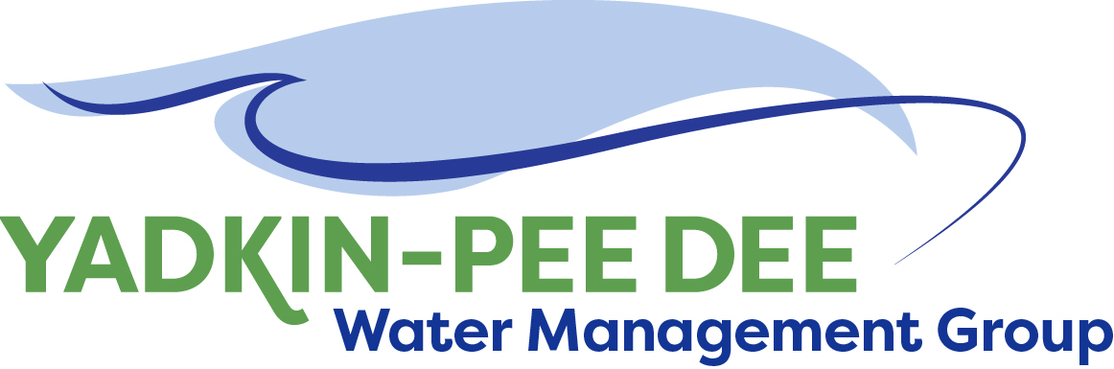
Yadkin-Pee Dee Water Management Group

Meeting Notes
Yadkin-Pee Dee Water Management Group Meeting
1:15PM to 2:45PM, August 20, 2020
Virtual Meeting (Zoom)

Agenda
- Welcome & Review of Agenda
- Legislative Update – Demetrius Deloatch, NCLM
- YPDWMG Member Forum
- YPDWMG New Member Outreach – Jim Behmer, Warren Miller
- HDR Project Update – Jonathan Williams
- Member Session

Legislative Update – Demetrius Deloatch, NC League of Municipalities
Demetrius Deloatch, Government Affairs Associate for the North Carolina League of Municipalities (NCLM), provided a legislative update. His topics included an overview of NCLM, an update on funding for utilities, relevant executive orders, replacement revenue, and a political overview of what is going on at both the state and federal level.

NCLM Overview:
The NCLM represents cities and towns before the General Assembly and US Congress. They send a legislative bulletin that goes out every Friday (brief overview of what’s happened in DC and Raleigh) register at CRM@nclm@.org. Subject line: “Bulletin Registration.”

Funding for Utilities
Utility systems
- HB 1087/SB 810 – signed into law July 1. NCLM worked with SOG, DEQ Water Infrastructure, and more over 2 years. The bill concerns Viable Utility Reserve and provides $9 million in non-recurring funds as a start, targeting financially struggling water systems. It directs DEQ to study inter-basin transfers. More details can be found on page 9, SS 4 of HB 1087.
- HB1200 – Foreclosure Grants/Rental & Utility & Assistant – takes CARES Act Money. Bill proposes $100 million, with no more than $1800 to each eligible participant. It is eligible to be considered in the September session.
- HB 873 – signed into law June 30. Will change System Development Fee payment timing, clarified use of certain system development fee revenues to pay debt. Made regulations for accessory dwelling unit sewer service lines more workable.

Executive Orders
- EO 124 – enacted March 31, 2020 – prohibited disconnections for nonpayments and prohibited collection of late fees. Encourage to reconnect homes previously disconnected
  - Encouraged telecommunications (cable internet) to follow same guidelines
  - Prohibited evictions and new rental bonds
- EO 142 – May 30, 2020 – extended prohibitions until July 29
- Now they’ve both expired. Treasurer Falwell spoke out against it. Discrepancy among NC Council of State about possibility of extension

Political Overview
- With a big election coming up and North Carolina being a swing state plus having newly re-drawn district maps, lots of eyes are on NC
- This year the supermajority in the General Assembly was broken
- Senate needs +5 Dems for majority, House needs +6
- Lots of retirements – David Lewis (rules chairman), senators have retired (22 senate 12 in house)

Short Session
- Usually short and only to make changes to budget, but this year different
  - April: COVID relief bill
  - May 18: looked at vetoes filed
  - July: clean up going on
    - Oversight committee meetings
  - September: finish biennium, possibility of special session
- $700 million of CARES Act fund, needs to be spent by December
- Because supermajority in General Assembly was broken, Cooper’s vetoes can’t be overridden

Replacement revenue
- Municipalities struggling financially because of COVID-19 impacts
- $599 million shortfall on behalf of cities and towns
- CARES Act: NC got $4 billion – needs to be spent by December 2020. Of that money. $300 million - $150 million to counties, $150 million in reserve. Only 25% has to be shared with cities & towns ($17.5 million)
- NCLM pushing federal gov’t for more funding and flexibility

YPDWMG Member Forum
Hydrologic Model Technical Review Committee
Result of letter sent on 13th provided assurances we’re looking for. NCDWR is working with Steve N.
Waiting for confirmation based on Doodle poll, but it looks like TRC is getting together September 1st. Anyone interested can get in touch with Jonathan Williams.

Pam Behn (NCDWR) asked if the group had any questions for DWR. She noted it’s important to have TRC involvement through model development. Data gathering stage is time-consuming, plus COVID has pushed it back. A database transfer caused 2 month delay. She gave an overview of model timeline. The contract is through the end of this calendar year. She’ll have better schedule after TRC meeting. Looks like will still be able to finalize by end of year.

Other member updates
- Aubrey Lofton, Union County, approved contract – begin construction of pipeline on Lake Tillery
- Ron Hargrove, Charlotte, embarking on own large project – selected design build teams to build Mount Holly facilities and conveyance. Over next 30 days, they will hopefully know more details because it came out over budget. Selected place for new wastewater plant. Stowe Wastewater Treatment Plant – Reuse and Resource Reclaiming facility. They have selected a team, and yesterday had final workshop to pick process for the facility. Narrowed to two, both would be somewhat innovative/firsts in North Carolina.
- Jim Behmer, Salisbury, county has expressed interest. Started project on filters and centrifuge.
  - Finished Fourth Street project
- Bill Brewer, Winston-Salem, bid basically doubled what they’d expected (estimated $55-70 million, bids came in around $110 million). Project pushed back to August. Working to secure additional funding and revisit this spring. AMI is moving forward; selected vendor is evaluating all of tanks. 48MGD gallons/day.

YPDWMG Outreach

The YPDWMG wants to pick outreach back up and help grow and maintain membership.
Warren Miller, Fountainworks, noted he appreciated those who have done outreach (notably, Bill Brewer, Aubrey Lofton, Jim Behmer, and Ron Sink). We halted back in March when COVID-19 hit, but now the time is right to re-start outreach. They’ll be doing one-on-one calls to gauge interest. The more that participate, the stronger the group will be.

HDR Project Update – Jonathan Williams
- WRP Framework: Set it up with critical milestones and available funding. Decided to go with Plan C – spread investment over several years.
- Right now: Completed Phase 1 (visioning and demand forecast 2018-2019) . Now, we’re wrapping up Phase 2 (wrapped up with delivery of scenario development and stakeholder Advisory Committee).
- Phase 3 is in progress. Water Quality Model – NCDEQ working with Hazen & Sawyer
- Phase 4 – when we get into model evaluation to evaluate scenarios for phase 2. Scheduled for early 2021.
- We’ve started work on Phase 5 through some money from Duke Energy and some other members. Began Phase 5b around water quality – developing strategies to do additional research on key issues that will affect quality, and potential mitigation strategies. 2020-2022
- As we talk more about next task order, we’re proposing to start Phase 5a – there's work that can be started to advance that that doesn't require any modeling.
- 2023: Mitigation strategies and evaluation. Then all of that would be rolled into Master Plan, roll out to public and governing boards in 2024 for Phase 7.

Final Scenario Selection Summary
- Have final 13 scenarios. We finalized technical memorandum and identified how they’d be evaluated. Make sure Pam & Neela (DWR) have a copy of the selection summary
- Group honed in on about 10 scenarios that need to be analyzed. Some of water quality ones aren’t necessarily evaluative, more desktop
- Draw attention to last three scenarios (insert screenshot)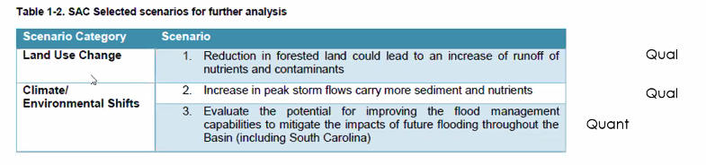
- Technical memorandum that was sent out is final document.
Stakeholder Advisory Committee
- Had a meeting July 16th
  - It was the second meeting of group
  - Purpose: review scenario document and get input on water quality work. Through August 9th. Gotten feedback from lots of stakeholder groups.
  - Next meeting: October 15th 10AM-12PM (likely virtual)
  - Note to Pam: At next meeting, want to give group update on Water Quality Model and review other document.

Water Quality Update
- Phase 5b – Identify future water quality issues in the Basin...
  - Task 1: ...By evaluating previous water quality studies and models
  - 2: ...that are subject to current, and possible future, rules and regulations
  - 3: ...that are addressed by watershed protection
  - 4: ...and summarize within the basin by compiling the reviewed information.
  - 1-3 are completed; now have draft summary report of tasks 1-3, sent to group earlier this week.
  - Basically: figure out what has been done and could be done, identify gaps.
  - Able to start now because of extra funding from Duke and group

Two main categories
- Contaminants of Emerging Concern
- Expand nutrient and chlorophyll-a monitoring

Recommended Water Quality Monitoring and Study – CECs
We are proposing to create baseline understanding. How does YPD basic stand next to other basins in NC and other states setting MCLs?
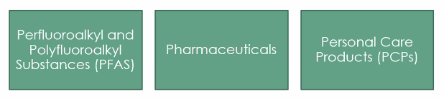
Using EPA guidance, coordinating with NCDEQ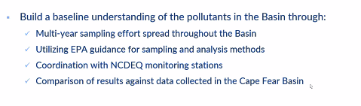
- Better understand pollutants beyond High Rock Lake – what we need to do from monitoring standpoint is understand where the next water body in basin known pollutants like chl-a will have an impact.
- What can we do basin-wide?
- Recommending leveraging YPDRBA and DWR Ambient monitoring stations and filling in geographical gaps

Water Resources Plan – Next Steps
- Proposed activities for Phase 5a
  - 1: Funding Assistance Planning ($15k)
    - Proposed last year, group had held off, but Warren & Jonathan talked and feel we’re at the point now to keep moving with momentum, it’d be good to seek outside funding. Proposing to work with group over next 8 months to have plan for pursuing outside funding.
    - Will coordinate and communicate with funding agencies, prepare applications packages and grant writing assignments
    - Basically identify 3 best grants to apply for
  - 2: Strategic Communications Support ($15k)
    - How to implement plan relative to Water Resources Plan
    - Develop library materials
      - PPT template
      - Up to 3 infographics
      - Messaging guide
    - Gather and organize contact info (elected officials, community orgs, etc.)
    - Social media content and schedule
    - Develop website content for YPDWMG
  - 3: W. Kerr Scott Water Supply Allocation Study Recommendations ($25k)
    - Wilkes County & City of W-S have agreement with Army Corps of Engineers for water supply. Look at potential of increasing water supply allocation from reservoir
    - Framework guide of everything that’ll need to be done from study standpoint; looking through regulatory hurdles
    - Corps is engaged with Stakeholder Advisory Committee
    - Benefits everyone throughout basic because it’s at headwaters; reserve is safety net

  - 4: Water Demand Management & Conservation Evaluation ($43k)
    - Conduct a benchmarking survey for YPD River Basin water utilities to assess current water conservation efforts within the basin as compared to the other successful regional programs
    - Evaluate opportunities for future water demand management/conservation programs for basin water utilities
    - Quantify financial impacts and implications of water demand and conservation practices to water utilities
    - Develop a framework and goals for a potential Yadkin-Pee Dee water conservation program
- Start beginning of October – June 1, 2021. $98,000 total.

Meeting Attendees

Ron Hargrove, City of Charlotte
Jason Martin, Davidson County
Ron Sink, Davidson Water
Johnny Lambert, Davie County
Ed Bruce, Duke Energy
Jeff Lineberger, Duke Energy
Gerald Faulker, City of Kannapolis
Russell Colbath, City of Monroe
Jim Behmer, Salisbury-Rowan Utilities
Andy Smith, City of Statesville
Aubrey Lofton, Union County
Bill Brewer, City of Winston-Salem

Non-Member Attendees:
Warren Miller, Fountainworks
Maddie Shea, Fountainworks
Jonathan Williams, HDR
Demetrius Deloatch, NC League of Municipalities
Pamela Behn, NCDWR
Neelufa Sarwar, NCDWR
Virginia Baker, NCDWR

