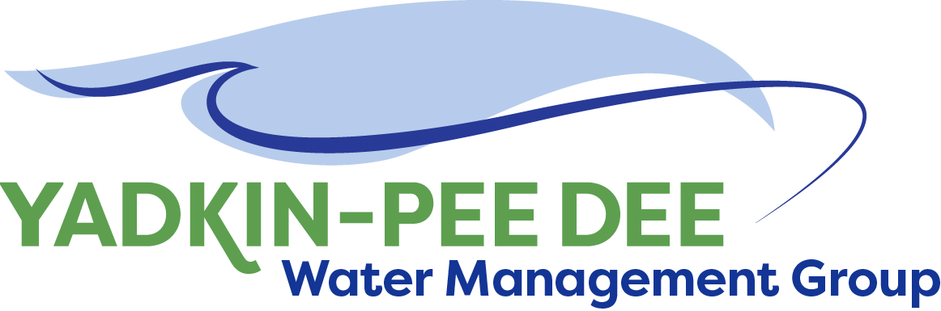
Yadkin-Pee Dee Water Management Group

Meeting Notes
Yadkin-Pee Dee Water Management Group
Meeting Notes: Special Meeting
1:00 PM-2:00 PM, April 22, 2021
Virtual Meeting (Zoom)

Introduction
The YPDWMG currently operates under an MOU, which expires on June 30, 2021. Over the past several months, a subcommittee (the Structure Committee) of YPDWMG members have been meeting to discuss future options for the structure of the Group.

The YPDWMG had a regular meeting on April 1, 2021, during which the subcommittee was scheduled to present their recommendations. However, other items on the agenda ran over. The Group decided it would be prudent to schedule a special meeting to ensure members could have a full discussion about the recommendations. This document provides additional context about the Structure Committee’s process in coming to their recommendation.

Process
Chair Jim Behmer opened the meeting, noting that this is an important conversation. Warren Miller provided an overview of the Structure Committee’s process.

Committee
The Structure Committee included Bill Brewer (City of Winston-Salem), Ed Bruce (Duke Energy), Ron Hargrove (City of Charlotte), and Jeff Lineberger (Duke Energy). The Structure Committee has met once a month from January to March 2021. A fourth meeting is currently being planned.

Background Research
At the first meeting, the subcommittee heard from representatives of two similar organizations, the Jordan Lake Partnership (JLP) and the Catawba Wateree Water Management Group (CWWMG). The JLP operates under an MOU, and the CWWMG is incorporated as a 501(c)(3) tax-exempt organization. At the meeting, Sydney Miller represented the JLP, and Barry Gullet represented the CWWMG. Both provided an overview of their organizations, the rationale for choosing to either operate under an MOU or incorporate, and shared a few benefits and downsides about the structure of each organization. The Structure Committee members asked questions on topics such as project management, financial management, partnerships with other organizations, and grant funding.

At the second meeting, the group reviewed the Structure Comparison Chart, which summarizes the key differences between an MOU and a 501(c)(3).
- MOU Overview: The Group’s current MOU is a non-binding agreement. The YPDWMG’s current MOU allows members to be governmental entities, public water utilities, or reservoir operators providing service within or using the water resources of the Basin.
  - Pros: MOUs are a familiar structure to local governments, provide a great deal of flexibility, and are relatively easy to establish or amend.
  - Cons: As it currently stands, the YPDWMG cannot enter into contracts on its own (need to designate a member). It also requires a member for project management, management of funds, etc. Finally, because it is not a permanent structure, MOUs can be more vulnerable to the political will of local elected officials.
- 501(c)(3) Overview: 501(c)(3)s are standalone, tax-exempt organizations. A 501(c)(3) is a binding legal agreement with established bylaws, and is subject to IRS regulations and legal requirements under the North Carolina Nonprofit Corporation Act (G.S. Chapter 55A).
  - Pros: A nonprofit can enter into contracts and receive/manage funds on its own. The administrative and risk burden are distributed more evenly across members. Additionally, incorporating can alleviate some of the bureaucratic slowdowns that local governments must go through (ex: shorter and simpler RFQ/RFP processes). Being a 501(c)(3) greatly expands an organization’s eligibility for grant funding. A less concrete, but important benefit is that it creates a sense of permanence.
  - Cons: 501(c)(3)s are less flexible; it can be difficult to change the bylaws. Though not technically required, each council/commission would likely need to sign off on a resolution for their government to join. They also require additional expenses, such as financial audits and insurance.
The group also briefly discussed options to merge with either the CWWMG or the Yadkin-Pee Dee River Basin Association, but ultimately decided against such an option. At this meeting, the Structure Committee decided the Group would benefit from eventually incorporating as a 501(c)(3). They chose to recommend that the YPDWMG extend its MOU for the next five years (until 2026), so that the Water Resources Plan (the main project the Group is undertaking) will be complete and the Group will have ample time to gather documents, get elected officials approval, and prepare to incorporate.

Between the second and third meeting, Fountainworks interviewed representatives from organizations including the Three Rivers Land Trust and Blanche & Julian Robertson Family Foundation to learn about their funding to 501(c)(3) vs. non-incorporated organizations. The bylaws of the Three Rivers Land Trust do not prevent it from giving money to an MOU organization. The Blanche & Julian Robertson Family Foundation provides funding to 501(c)(3)s and government departments and divisions, meaning that currently the YPDWMG would have to elect a member government to apply for any funding. Generally speaking, most larger foundations only provide funding to registered nonprofits.

Financial Gap Analysis
Fountainworks worked with HDR to conduct a financial gap analysis that shows the YPDWMG’s current funding, revenues, and anticipated expenses through FY2026. The analysis assumed no additional grant funding and no increases in membership dues. The analysis shows that by FY2023, the Group’s financial position would become a deficit. The Structure Committee spent the majority of its third meeting exploring ways to create a more sustainable funding pathway for the Group.

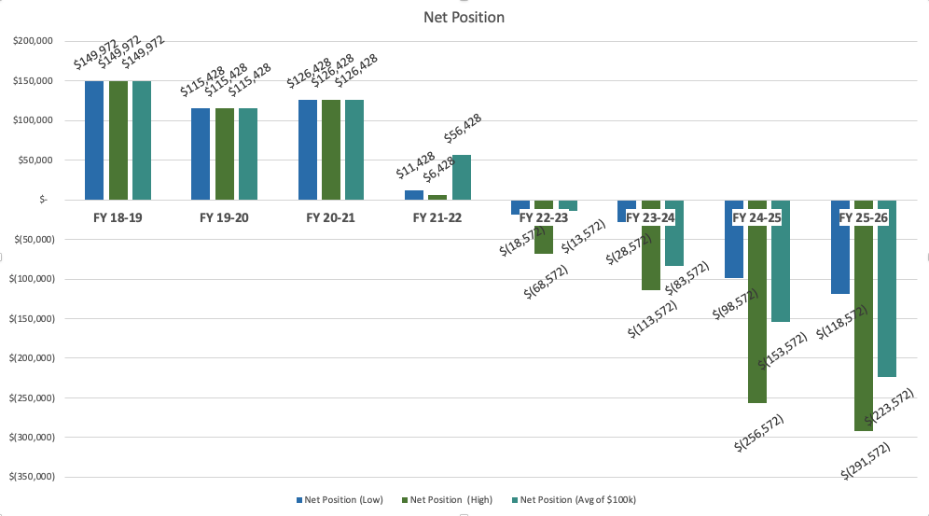
Screenshot of original gap analysis, assuming no increase in dues and no additional grant funding. For a dynamic view, the full analysis is available here (first tab).

The members noted that not every member organization would be able to continue as a member if dues were significantly raised, so the idea to create a third, higher tier (proposed at $10,000) for larger members was suggested. Additional funding may also be based on voluntary contributions, in accordance with the MOU. If 6-8 of the larger member organizations can pay increased dues over the next several years, the Group would not have to necessarily rely on large amounts of grant funding (though some would likely be needed). During the April 22nd Special Meeting, a question was raised about whether the gap analysis accounted for the State paying for the hydrologic model. The analysis does indeed account for this, and that cost is not built into the projections.

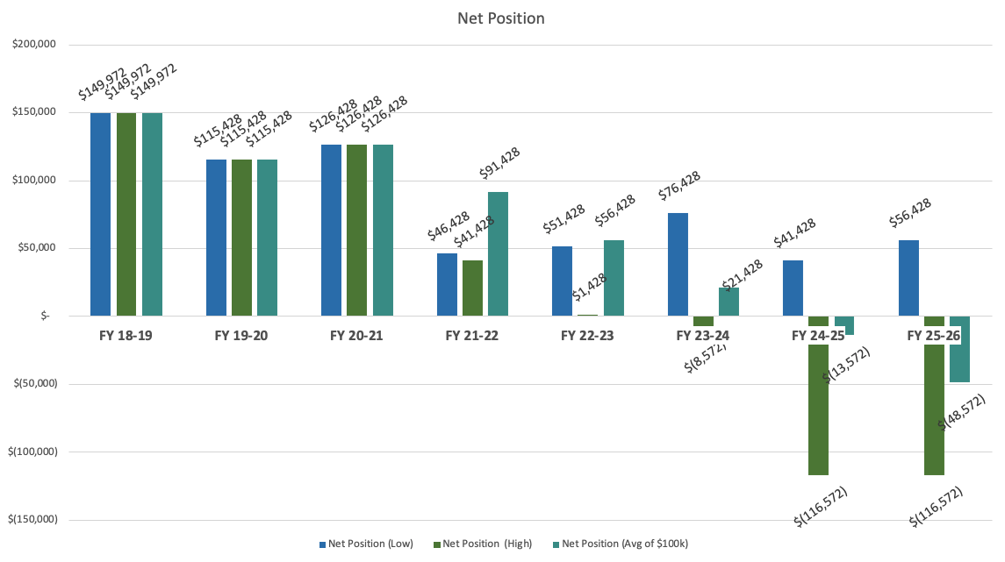
Screenshot of projections through FY2026 if 7 member organizations paid $10,000 per year. For a dynamic view, the full analysis is available here (second tab).

For additional context, the Jordan Lake Partnership has three membership tiers between $9,000 and $27,000 pear year. The Catawba Wateree Water Management Group’s dues currently ranges from $2,800 to $264,000 per year.

Fountainworks has communicated with larger members (systems with 10+ MGD and mainstem reservoir operators) to identify their tolerance for paying higher fees. Again, two options are to (1) amend the Group’s dues structure, or (2) it may also be prudent to make additional contributions voluntary and project-based, in accordance with the MOU, and reevaluate next year. A final decision on fees has not been made.

Recommendation & Next Steps
The recommendation is to extend the MOU by five years. It is the intent of the YPDWMG to incorporate as a 501(c)(3) nonprofit organization during this time. The MOU can be extended with unanimous written agreement of the members, and Fountainworks agreed to prepare a letter that members could have signed that would serve as such written agreement.

The Structure Committee is tasked to report back in 60 days (June 22, 2021) with recommendations on fee structure. Fountainworks is consulting with the City Attorney of Salisbury to identify any additional implications to the MOU or the Group.

Meeting Attendees
Alex Anderson, City of Kannapolis
Karen Baldwin, Cube Yadkin
Jim Behmer, Salisbury-Rowan Utilities
Bill Brewer, City of Winston-Salem
Ed Bruce, Duke Energy
Russell Colbath, City of Monroe
John Crutchfield, Duke Energy
Joyce Foster, Cube Yadkin
Johnny Lambert, Davie County
Aubrey Lofton, Union County
Jason Martin, Davidson County
Ron Sink, Davidson Water
Jonathan Williams, HDR
Dan Worl, City of Albemarle

Non-Member Attendees:
Warren Miller, Fountainworks
Maddie Shea, Fountainworks

